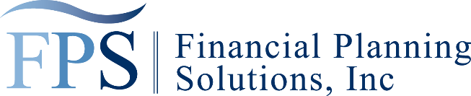

Shelley Lee Boyce, CFP®, AIF®

2784 Gateway Road, Suite 102 | Carlsbad, CA 92009 | 760.929.1180

slboyce@financialdesign.net | www.financialdesign.net

**DOCUMENTS NEEDED FOR FINANCIAL PLANNING**

THE FOLLOWING DOCUMENTS WILL BE NEEDED FOR THE PURPOSE OF STUDY AND ANALYSIS IN AN EFFORT TO PREPARE A PERSONAL FINANCIAL PLAN FOR YOU. IT IS UNDERSTOOD THAT THIS MATERIAL WILL BE TREATED CONFIDENTIALLY AND RETURNED AS SOON AS THE PLANNING PROCESS IS COMPLETED, OR AT AN EARLIER TIME IF REQUESTED.

ITEMS RECEIVED FROM ________________________________________________

|  |  |
| --- | --- |
| Most Recent Payroll Stub  ❑ Self  ❑ Spouse  Income Tax Returns for the Last Three Years  ❑ Self  ❑ Spouse  Personal Employment Benefit Statements  ❑ Self  ❑ Spouse  Company Benefit Plan Booklets  (Group Pension Plans)  ❑ Your Employer  ❑ Spouse’s Employer  IRA Statements  ❑ Roth  ❑ SEP  ❑ IRA  ❑ IRA Rollover  ❑ 401(k)  Most Recent Social Security Statements  ❑ Self  ❑ Spouse | Insurance & Annuity Contracts  ❑ Life Insurance  ❑ Health Insurance  ❑ Hospital & Major Medical  ❑ Disability Insurance  ❑ Automobile Insurance  ❑ Property and Casualty  Statements of Bank Accounts, Stocks, Bonds or Other Investments  ❑ Self  ❑ Spouse  Mortgage Statements  ❑ Primary Mortgage Statement  ❑ Second Mortgage Statement  ❑ Home – Equity Line of Credit  Statement  Wills/Trusts  ❑ Self  ❑ Spouse  Business Arrangements  ❑ Buy/Sell  ❑ Deferred Compensation  ❑ Stock Option/Bonus Plan |

___________________________________ Shelley Lee Boyce, CFP®, AIF®

Signed

ITEMS RETURNED DATE _____________ SIGNED _______________________

Shelley Lee Boyce is a Registered Representative with/and Offers Securities through Commonwealth Financial Network, Member FINRA/SPIC. CA Insurance Lic. #076122